**Continuing**

**Education**

**Program**

**on Computer for Computing and Information Technology**

**Faculty of Engineering University of Indonesia**

**ISAS(Information Search and Analysis Skill)**

**“Github Version Control System in Ubuntu”**

**Group :**

**Ian Andika D. S.**

**M. Hudya Ramadhana**

**Mutia Ayu Dianita**

**­­**

**Faculty : Dudy Fathan Ali, S.Kom**

**Class :2 SC 1**

3rd Floor Engineering Center Building

Faculty of Engineering University of Indonesia

Depok 16424

2016

**PREFACE**

First of all, The writer would like to say the biggest thanks to Allah SWT for giving us talent and idea, and because of Allah SWT’s grace and mercy we can finish doing this ISAS. Second, our gratitude goes to Dr. Aries Subiantoro ST, M.Sc as director of CCIT Engineering Faculty Universty of Indonesia.

There are so many problems in terms of finishing this report. But with help, guidance, motivation, and encouragement from others as well so the writer can finish this report.Because of that, the writer would like to say thanks toour faculty, Mr. Dudy Fathan Ali who gave us knowledge, skill, guidance and also his signature so we can complete the ISAS. Also our friends who gave us help, motivation, and encouragement to finish this ISAS.

We hope this report can give good information to the readers and influential for IT developments. The writers are obviously imperfect in making ISAS because the perfection just belongs to Allah SWT. we welcomes constructive criticisms and suggestions for our improvement.

Depok, May 2016

` Author

**TABLE OF CONTENTS**

PREFACE ii

TABLE OF CONTENTS iii

TABLE OF FIGURE iv

TABLE OF TABLE v

**CHAPTER 1 INTRODUCTION**

I.1 Background 1

I.2 Writing Objective 2

I.3 Problem Domain 2

I.4 Writing Methodology 2

I.5 Writing Framework 2

**CHAPTER II BASIC THEORY**

II.1 Operating System 5

II.2 Linux 6

II.3 Ubuntu 6

II.4 Github 7

**CHAPTER III PROBLEM ANALYSIS**

III.1 How to Install Github in Ubuntu 8

III.2 Github Version Control System Features 12

**CHAPTER IV CONCLUSION AND SUGGESTION**

IV.1 Conclusion 14

IV.2 Suggestion 14

**BIBLIOGRAPHY**

**TABLE OF FIGURE**

Figure 3.1 Training Github Directory 8

Figure 3.2 Make a File 9

Figure 3.3 Ubuntu Terminal 9

Figure 3.4 Open Directory 10

Figure 3.5 Directory Repository 10

Figure 3.6 Add File 10

Figure 3.7 Version Control 11

Figure 3.8 New Repository 11

Figure 3.9 Remote Repository 11

Figure 3.10 Push and Pull 12

Figure 3.11 Input Username and Password Github 12

Figure 3.12 Data Uploaded 12

Figure 3.13 Branch 12

Figure 3.14 New Branch 13

Figure 3.15 Clone Folder 13

Figure 3.16 Check File 13

Figure 3.17 Check Github Folder 13

**CHAPTER I**

**INTRODUCTION**

**I.1 Background**

Programming Language founded before 1940. In that era, programming language still using 0 and 1 as the language. The language is called machine language. Machine language is language which consist of machine code and only can be interpreted by computer machine. Machine language classified low level language, it’s because still using 0 and 1.

After internet founded, some of people still using traditional way to exchange their program. In that case, we should copy the code into the media disk such as floppy disk or flash disk.The impact of copying file code will make the classified coding so hard, as example first when we make a file code HelloWorld.py and we want to update a new coding inside the HelloWorld.py we should make the file look like this HelloWorld-FIX.py. It will make the classified program very hard.

In 2008, Team of Github [Tom Preston-Werner](https://en.wikipedia.org/wiki/Tom_Preston-Werner" \o "Tom Preston-Werner), Chris Wanstrath, and PJ Hyett make an online repository so programmer can upload, download, and update their code with a version control. This idea give a good impact to the all programmer. Programmer can easily control the version of code and it will detect who upload the code. The system is very complex and secure, the structure of repository created with a good visual.

Github bring easiness to all programmer until today. Github is not only as the online repository, but also as the forum of programmer when a repository needed by another programmer. Another programmer can also make a comment inside the coding so the creator and another programmer can discuss about the code not by the file, but it can be commented each line code. Github is a standard place to the programmer, a lot of professional programmer always using Github as the repository to save their code.

Github also used by the programmer to save their work inside there. When sometimes programmer need the code, they can found easily their code inside their repository. Github bring easiness to all programmer to modify their code and save their code online. There are no limit to make a lot of repository in each account. But github make a limit maximum 100MB each file to upload in the repository.

In this project, author discuss about “Github Version Control in Ubuntu”. Author hope this project will help new programmer to utilize Online Repository as their equipment to save their code and their program.

**I.2 Writing Objective**

The purpose of this Project is people will know more about Linux Ubuntu and How to install and use Github Version Control System in Ubuntu

**I.3 Problem Domain**

Accordance with the title of Project " Github Version Control System in Ubuntu " We will discuss about how to install Github Version Control System in Ubuntu, Push and Pull in Github Version Control System in Ubuntu.

**I.4 Writing Methodology**

The method which used in this Project is the method of browsing from internet, read someone review article, experience, and make a survey in problem domain.

**I.5 Writing Framework**

To know the description of this paper, the we divides it into four chapters. Eachchapter in this study are interconnected between chapters with chapter one another bysystematic writing as follows:

**CHAPTER I: INTRODUCTION**

**1.1 Background**

Discusses the history of Ubuntu and Github and the reason why Ubuntu and Github come.

**1.2 Writing Objective**

The purpose of this article is to understand about Linux, and all information about Github in Ubuntu

**1.3 Problem Domain**

Mention several points about the problem of Github Version Control System in Ubuntu, there are how to install Github Version Control System in Ubuntu, how to use Github Version Control System in Ubuntu , and how to push and pull in Github Version Control System in Ubuntu.

**1.4 Methodology Writing**

To get data which needed, Author use the method of observing or direct observation techniques.. Not only that, Author also browsing for the material and sources from electronic mass media which reaching internasional, that is internet.

**1.5 Writing Framework**

Author Writing Framework consists of four Chapter, the first chapter is introduction which tells the background, writing objective, several problem domain, methodology writing and writing framework of this paper.

**CHAPTER II: BASIC THEORY**

In chapter II, Author write several sub chapter. The first sub chapter is to tell about Operating System, The second sub chapter is to tell about Linux. The third sub chapter is to tell about Ubuntu. The fourth sub chapter is to tell about Github.

**CHAPTER III: PROBLEM ANALYSIS**

Analyzing and solve the problem that contained in problem domain.

**CHAPTER IV: CONCLUSION AND SUGGESTION**

Conclude and suggest related to this paper.

**CHAPTER II**

**BASIC THEORY**

**II.1 Operation System**

An operating system is the most important software that runs on a computer. It manages the computer's memory, processes, and all of its software and hardware. It also allows you to communicate with the computer without knowing how to speak the computer's language. Without an operating system, a computer is useless.

Operating System (OS) manages all of the software and hardware on the computer. Most of the time, there are many different computer programs running at the same time, and they all need to access your computer's central processing unit (CPU), memory, and storage. The operating system coordinates all of this to make sure each program gets what it needs.

Operating systems usually come preloaded on any computer you buy. Most people use the operating system that comes with their computer, but it's possible to upgrade or even change operating systems. The three most common operating systems for personal computers are Microsoft Windows, Apple Mac OS X, and Linux.

Modern operating systems use a graphical user interface, or GUI (pronounced gooey). A GUI lets you use your mouse to click icons, buttons, and menus, and everything is clearly displayed on the screen using a combination of graphics and text.

Each operating system's GUI has a different look and feel, so if you switch to a different operating system it may seem unfamiliar at first. However, modern operating systems are designed to be easy to use, and most of the basic principles are the same. Before GUIs, computers had a command-line interface, which meant users had to type every single command to the computer and the computer would only display text.[1]

**II.2 Linux**

Linux is an operating system developed by Linus Benedict Torvalds at the University of Helsinki Finland as a hobby project began in 1991. He wrote Linux, a kernel for the 80386 processor, the first processor 32-bit Intel CPUs in a collection suitable for PC. It was not until March 14, 1994 version 1.0 was released, and this is a milestone in the history of Linux.

Linux is a clone of UNIX that had been the port to the multiple platforms,among others: Intel 80 × 86, AlphaAXP, MIPS, Sparch, Power PC, etc. Approximately 95% of the same kernel source code for all hardware platforms.

Including the Linux operating system is distributed as open source, meaning that the Linux source code is included so it can be studied and developed with ease. Besides Linux developed by the GNU (General Public License).

Linux can be used for various purposes, such as: network, software development, and as an end-user platform. So far, Linux became the operating system a lot of attention because of the sophistication and the price is relatively cheap compared with other operating systems. Various Linux distributions include: Stackware, Debian, RedHat, Suse, Caldera, and Turbo Linux.[2]

**II.3 Ubuntu**

Linux was already established as an enterprise server platform in 2004, but free software was not a part of everyday life for most computer users. That’s why Mark Shuttleworth gathered a small team of developers from one of the most established Linux projects — Debian — and set out to create an easy-to-use Linux desktop: Ubuntu.

Ubuntu is an ancient African word meaning ‘humanity to others’. It also means ‘I am what I am because of who we all are’. The Ubuntu operating system brings the spirit of Ubuntu to the world of computers.

The vision for Ubuntu is part social and part economic: free software, available to everybody on the same terms, and funded through a portfolio of services provided by Canonical.

The Ubuntu team broke new ground in committing to a programme of scheduled releases on a predictable six-month basis. It was decided that every fourth release, issued on a two-year basis, would receive long-term support (LTS). LTS releases are typically used for large-scale deployments.

Ubuntu is different from the commercial Linux offerings that preceded it because it doesn’t divide its efforts between a high-quality commercial version and a free ‘community’ version. The commercial and community teams collaborate to produce a single, high-quality release, which receives ongoing maintenance for a defined period. Both the release and ongoing updates are freely available to all users.[3]

**II. 4 Github**

At the heart of GitHub is Git, an open source project started by Linux creator Linus Torvalds. Matthew McCullough, a trainer at GitHub, explains that Git, like other version control systems, manages and stores revisions of projects. Although it’s mostly used for code, McCullough says Git could be used to manage any other type of file, such as Word documents or Final Cut projects. Think of it as a filing system for every draft of a document.

Some of Git’s predecessors, such as CVS and Subversion, have a central “repository” of all the files associated with a project. McCullough explains that when a developer makes changes, those are made directly to central repository. With distributed version control systems like Git, if you want to make a change to a project you copy the whole repository to your own system. You make your changes on your local copy, then you “check in” the changes to the central server. McCullough says this encourages the sharing of more granular changes since you don’t have to connect to the server every time you make a change.

GitHub is a Git repository hosting service, but it adds many of its own features. While Git is a command line tool, GitHub provides a Web-based graphical interface. It also provides access control and several collaboration features, such as a wikis and basic task management tools for every project.[4]

**CHAPTER III**

**PROBLEM ANALYSIS**

**III.1 How to Install Github in Ubuntu**

How to install and make Github File version control on Linux Ubuntu

1. Make sure you have Github account . If you don’t have, please register at <http://github.com>
2. Install Github on your computer based on your OS. Please visit <http://git-scm.com/downloads>

* For linux open terminal and write

1. sudo apt-get update
2. After finish write “sudo apt-get install git”.

* Check git version “git –version”
* Config your account first before go
  + gitconfig --global user.name "Your Name"
  + gitconfig --global user.email "youremail@domain.com"

1. Go into directory of your computer, for example: “Training Github” directory

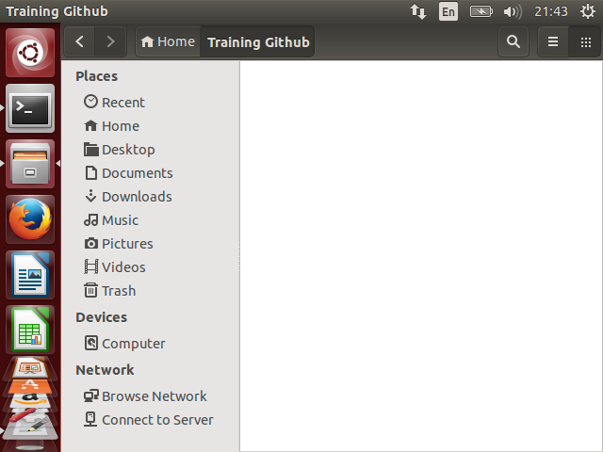

**Figure 3.1 Training Github Directory**

1. Make a file or choose one if you already have file inside it.

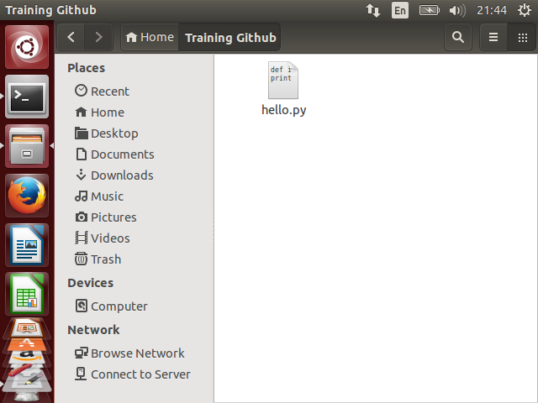

**Figure 3.2 Make a File**

1. Open Terminal in your Ubuntu

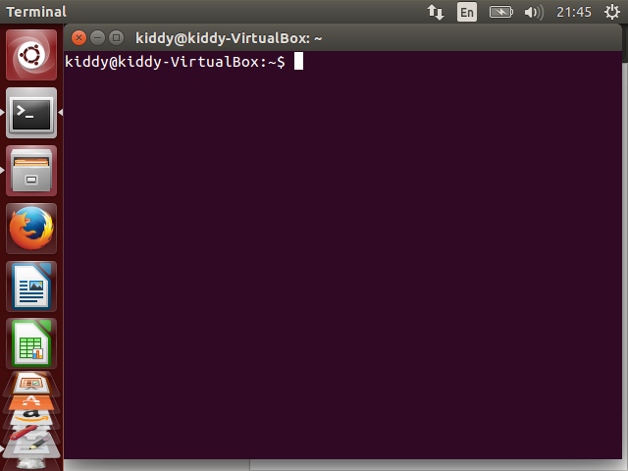

**Figure 3.3 Ubuntu Terminal**

1. Open your directory

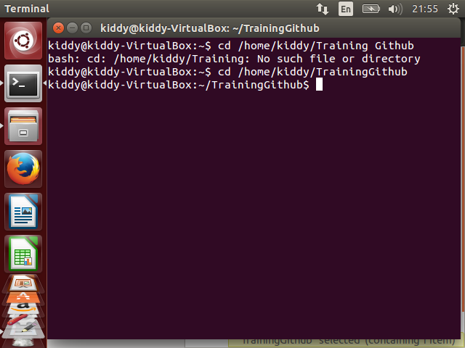

**Figure 3.4 Open Directory**

1. Type “git init” and push enter to make Training Github folder as directory repository of your computer

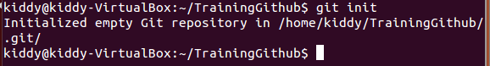

**Figure 3.5 Directory Repository**

1. Write “git add [your file]” to add file to the basket which ready to upload to github.
   1. Use command “git add .” to add all of data inside directory.
   2. Use command “git add [folder_name]” to add a folder to the basket.

C:\Users\KIDDY\Desktop\13.png

**Figure 3.6 Add File**

1. Write : git commit –m “Version 0.1”

this command is to make a notes to the file as Version Control.

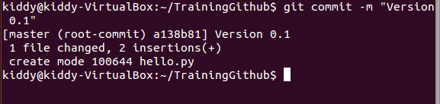

**Figure 3.7 Version Control**

1. Make a new Repository on your github

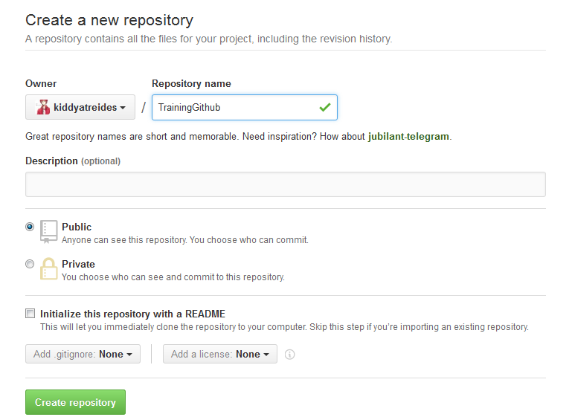

**Figure 3.8 New Repository**

1. Remote the repository of your github with two commands :
   1. git remote rm origin
   2. git remote add origin [http://github.com/[username]/[repository](http://github.com/%5busername%5d/%5brepository)]

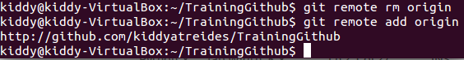

**Figure 3.9 Remote Repository**

1. You can use 2 commands here :
   1. “git pull origin master” to download all data inside the repository.
   2. “git push origin master” to upload all data from the basket.

C:\Users\KIDDY\Desktop\9.png

**Figure 3.10 Push and Pull**

1. Input your username and password github account

C:\Users\KIDDY\Desktop\11.png

**Figure 3.11 Input Username and Password Github**

1. Wait until data uploaded or downloaded

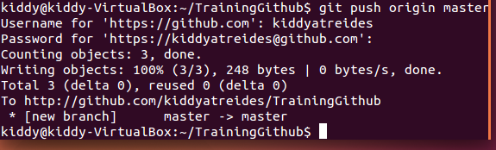

**Figure 3.12 Data Uploaded**

**III.2 Github Version Control Features**

There are some features that you can use in Github version control:

1. This command to see the branches that exist in our repository

C:\Users\KIDDY\Desktop\git-branch.png

**Figure 3.13 Branch**

1. This command to make a new branch in github

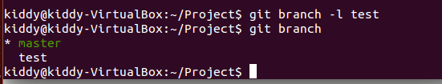

**Figure 3.14 New Branch**

1. This command to clone folder from repository

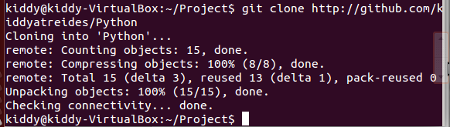

**Figure 3.15 Clone Folder**

1. This command is to check file that we added and the file that not added

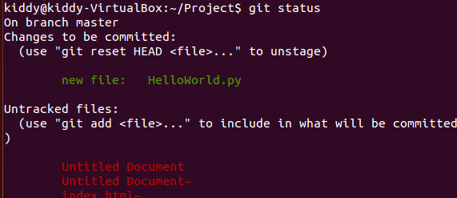

**Figure 3.16 Check File**

1. This command is to check our github version

C:\Users\KIDDY\Desktop\git-version.png

**Figure 3.17 Check Github Version**

**CHAPTER IV**

**CONCLUSION AND SUGGESTION**

**IV. 1 Conclusion**

Github is a online repository to save code of programming in cloud computing. With github we can control the version of each code to make programmer easy and understand what is the update when the code changed.

**IV.2 Suggestion**

There are some suggestions for the readers:

1. Using Github as Online Repository is good because the feature of Github is good and github is famous company in Online Repository.
2. Programmer must make the code more easy with the comment at the end of line code.
3. Programmer must understand the feature of github such as branch, clone and status to make their uploading easy.

**BIBLIOGRAPHY**

[1] <http://www.quora.com/What-is-an-operating-system-what-are-types-of-operating-systems/answer/Ameet-Khedkar?share=bfbbb4d1> [26/05/16]

[2] <https://www.linux.com/learn/new-user-guides/376-linux-is-everywhere-an-overview-of-the-linux-operating-system> [26/05/2016]

[3] <http://www.ubuntu.com/about/about-ubuntu> [28/05/2016]

[4] <http://www.techcrunch.com/2012/07/14/what-exactly-is-github-anyway/> [28/05/2016]